San Jacinto SUD
70 Church Avenue
Coldspring, TX 77331
1st Class MAIL
U.S. Postage
PAID
Coldspring, TX
Permit No. 101
SaN JACINTO SPECIAL
UTILITY DISTRICT
PWS ID # 2040033
San Jacinto Special Utility District
936-653-4384
PWS ID # 2040033

Este reporte incluye informacion importante sobre el agua para tomar. Si tiene preguntas o’discussiones sobre este reporte en espanol, favor de liamar al tel. 936-653-4384 par hablar con una persona bilingue en espanol.

What’s the Quality of My Water?
San Jacinto Special Utility District is pleased to share this water quality report with you. It describes to you, the customer, the quality of your drinking water. This report covers January 1 through December 31, 2012. San Jacinto SUD’s drinking water supply surpassed the strict regulations of both the State of Texas and the U.S. Environmental Protection Agency (EPA), which requires all water suppliers to prepare reports like this every year.

Our water source is groundwater pumped from four deep wells, all of which are located within the Coldspring City limits. Our wells draw from the Gulf Coast Aquifer. Our system has 120 miles of water service lines, which provide for about 1200 connections.

We are proud to announce that we have been recognized as a “State of Texas Superior Water System”

San Jacinto SUD treats your water using disinfection to remove or reduce harmful contaminants that may come from the source water. We employ five employees. Three of the five employees serve as our water maintenance team, whom are always striving to provide the best possible service to you, our customer. Our other two employees serve as our office staff, which always greet and meet the need of our customers as fast and as friendly as possible.

The TCEQ completed an assessment of your source water and results indicate that some of your sources are susceptible to certain contaminants. The sampling requirements for your water system are based on this susceptibility and previous sample data. Any detection of these contaminants may be found in this Consumer Confident Report. For more information on source water assessments and protection efforts at our system, contact Wes Isbell. For more information about your sources of water, please refer to the Source Water Assessment Viewer available at the following URL: http://gis3.tceq.state.tx.us/swav/Controller/index.jsp?wtrsrc= Further details about sources and source-water assessments are available in Drinking Water Watch at the following URL: http://dww.tceq.texas.gov/DWW

If you have any questions about this report or concerning your water utility, please contact San Jacinto Special Utility District by calling 936-653-4384 or by writing to this address: 70 Church Ave, Coldspring, TX 77331. We want our valued customers to be informed about their water utility. You can attend a scheduled public meeting on August 26, 2013, at 7:00 pm, at our office in Coldspring.

Board of Directors: Miller Thompson, President; Clay Currie, Vice President; Phil Runge, Sec./Treas.; Paul Shelton, Director; Buck Scarborough, Director

The U.S. Environmental Protection Agency (EPA) wants you to know:

In order to ensure that tap water is safe to drink, EPA prescribes regulations that limit the amount of certain contaminants in water provided by public water systems. Food and Drug Administration regulations establish limits for contaminants in bottled water that must provide the same protection for public health.

Drinking water, including bottled water, may reasonably be expected to contain at least small amounts of some contaminants. The presence of contaminants does not necessarily indicate that water poses a health risk. More information about contaminants and potential health effects can be obtained by calling the EPA’s Safe Drinking Water Hotline (1-800-426-4791).

The sources of drinking water (both tap water and bottled water) include rivers, lakes, streams, ponds, reservoirs, springs, and wells. As water travels over the surface of the land or through the ground, it dissolves naturally occurring minerals and, in some cases, radioactive material, and can pick up substances resulting form the presence of animals or from human activity.

A Cool

Drink Of Water.
2012 Annual Water Quality Report
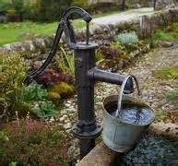
Notes:
The state allows us to monitor for some contaminants less than once per year because the concentrations of these contaminants do not change frequently. Some of our data, though accurate, is more than one year old.

While your drinking water meets EPA’s standard for arsenic, it does contain low levels of arsenic. EPA’s standard balances the current understanding of arsenic’s possible health effects against the costs of removing arsenic from drinking water. EPA continues to research the health effects of low levels of arsenic, which is a mineral known to cause cancer in humans at high concentrations and is linked to other health effects such as skin damage and circulatory problems.

The MCL for beta particles is 4 mrem/year. EPA considers 50 pCi/L to be the level of concern for beta particles.

Contaminants that may be present in source water include:

Microbial contaminants, such as viruses and bacteria, which may come from sewage treatment plants, septic systems, agricultural livestock operations, and wildlife.
Inorganic contaminants, such as salts and metals, which can be naturally – occurring or result from urban storm runoff, industrial or domestic wastewater discharges, oil and gas production, mining or farming.
Pesticides and herbicides, which may come from a variety of sources such as agriculture, urban storm water runoff, and residential uses.
Organic chemical contaminants, including synthetic and volatile organic chemicals, which are byproducts of industrial processes and petroleum production, and can also come from gas stations, urban storm water runoff, and septic systems.
Radioactive contaminants, which can be naturally occurring or be the result of oil and gas production and mining activities.

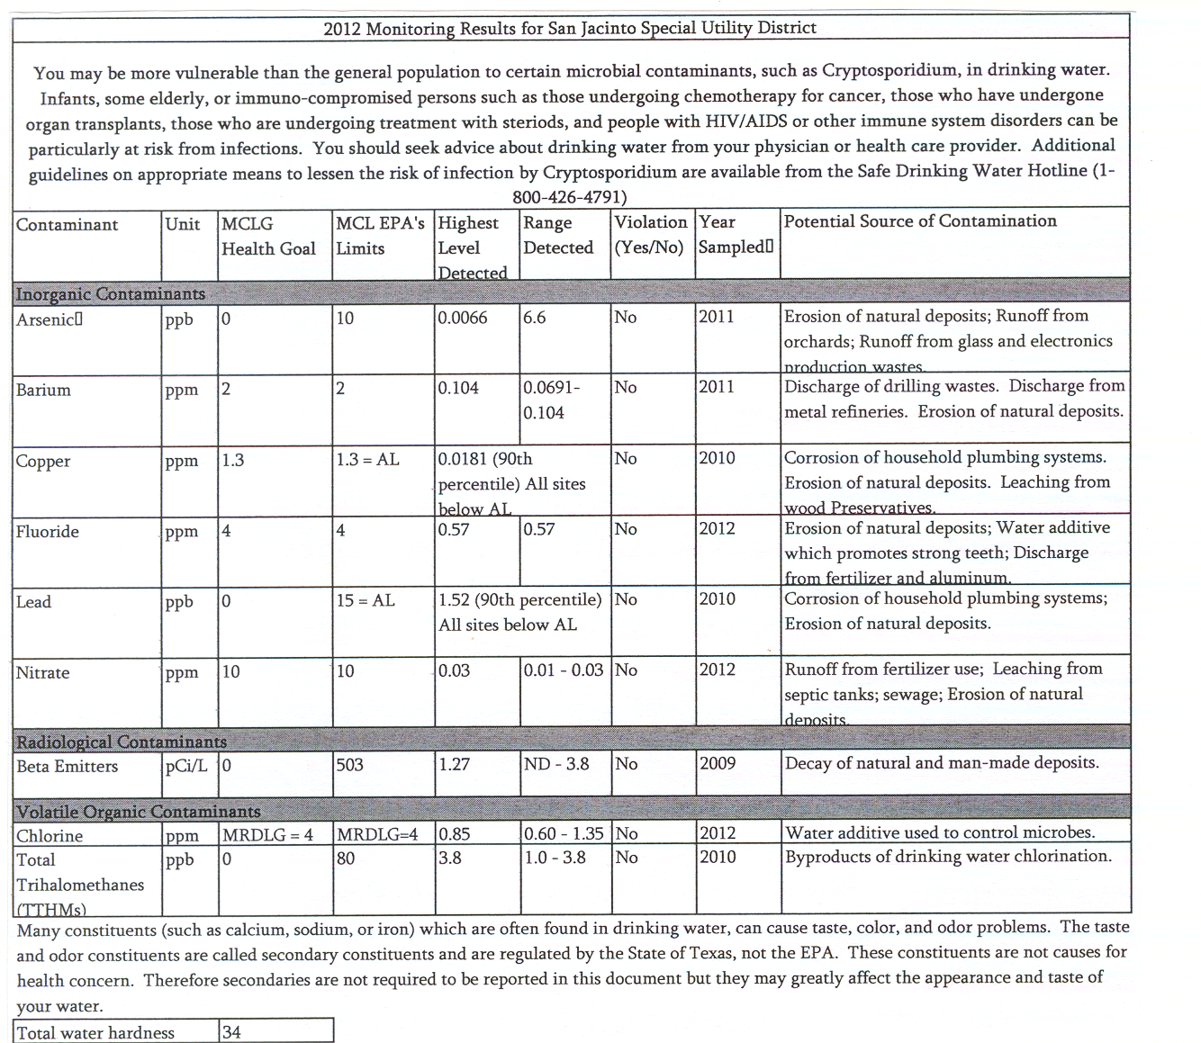
Polyphosphates are added to our drinking water to help with the hardness, taste and color. These phosphates are called NAP-201.
If present, elevated levels of lead can cause serious health problems, especially for pregnant women and young children. Lead in drinking water is primarily from materials and components associated with service lines and home plumbing. San Jacinto Special Utility District is responsible for providing high quality drinking water, but cannot control the variety of materials used in plumbing components. When your water has been sitting for several hours, you can minimize the potential for lead exposure by flushing your tap for 30 seconds to 2 minutes before using water for drinking or cooking. If you are concerned about lead in your water, you may wish to have your water tested. Information on lead in drinking water, testing methods, and steps you can take to minimize exposure is available from the Safe Drinking Water Hotline or at http://www.epa.gov/safewater/lead.
Definitions
Maximum Contaminant Level Goal (MCLG): The level of contaminant in drinking water below which there is no known or expected risk to health. MCLGs allow for a margin of safety.

Maximum Contaminant Level (MCL): The highest level of a contaminant that is allowed in drinking water. MCLs are set as close to the MCLGs as feasible using the best available treatment technology.

Maximum Residual Disinfectant Level Goal (MRDLG): The level of a drinking water disinfectant below which there is no known or expected risk to health. MRDLGs do not reflect the benefits of the use of disinfectants to control microbial contaminants.

Maximum Residual Disinfectant Level (MRDL) The highest level of a disinfectant allowed in drinking water. There is convincing evidence that addition of a disinfectant is necessary for control of microbial contaminants.

Action Level (AL): The concentration of a contaminant, which, if exceeded, triggers treatment or other requirements, which a water system must follow.

90th Percentile: 90% of samples are equal to or less than the number in the chart.

NA: Not applicable

MREM (millirems): A measure of radiation absorbed by the body.

ND: Not detectable at testing limits.

PPB (parts per billion): Micrograms per liter (ug/l)

PPM (parts per million): Milligrams per liter (mg/l)

pCi/L (picocuries per liter): A measure of radioactivity.

SU: Standard Unit

TCEQ: Texas Commission on Environmental Quality

